USER INTERFACE CABLE FRAME

- PARTS:

QUANTITY: PART #: NOMENCLATURE: LENGTH:

1 PER MACHINE 217064-4V CABLE, VGA FRAME EXT. N/A

1 PER MACHINE 217064-4B CABLE, B/W MONITOR N/A

1 PER MACHINE 217064-4H CABLE, HAND-HELD N/A

1 PER MACHINE 217064-4K CABLE, KEYBOARD N/A

1 PER MACHINE 217018- CABLE, VIDEO, CO-AX N/A

1 PER MACHINE 17649- RECEPTACLE, BNC BULKHEAD N/A

1 PER MACHINE 217064-4M CABLE, MOUSE N/A

1 PER MACHINE 215023- PLATE, ELECTRICAL N/A

2 PER MACHINE 18667- OUTLET, RECEPTACLE, 125VAC N/A

- ASSEMBLY:

- MANUFACTURE THIS ASSEMBLY ACCORDING TO DIAGRAM 1.
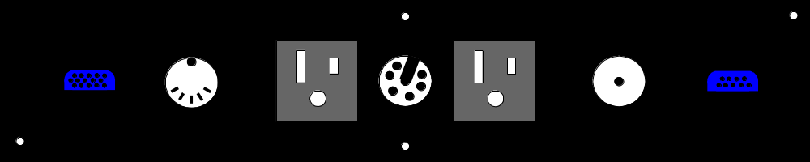

DIAGRAM 1

